Explanation of Bubble Sort

Let the elements of array are -

Bubble sort Algorithm

First Pass

Sorting will start from the initial two elements. Let compare them to check which is greater.

Bubble sort Algorithm

Here, 32 is greater than 13 (32 > 13), so it is already sorted. Now, compare 32 with 26.

Bubble sort Algorithm

Here, 26 is smaller than 36. So, swapping is required. After swapping new array will look like -

Bubble sort Algorithm

Now, compare 32 and 35.

Bubble sort Algorithm

Here, 35 is greater than 32. So, there is no swapping required as they are already sorted.

Now, the comparison will be in between 35 and 10.

Bubble sort Algorithm

Here, 10 is smaller than 35 that are not sorted. So, swapping is required. Now, we reach at the end of the array. After first pass, the array will be -

Bubble sort Algorithm

Now, move to the second iteration.

Second Pass

The same process will be followed for second iteration.

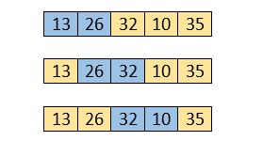

Here, 10 is smaller than 32. So, swapping is required. After swapping, the array will be -

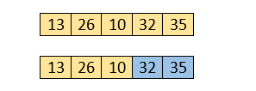

Now, move to the third iteration.

Third Pass

The same process will be followed for third iteration.

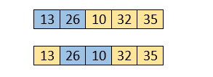

Here, 10 is smaller than 26. So, swapping is required. After swapping, the array will be -

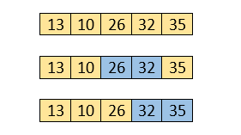

Now, move to the fourth iteration.

Fourth pass

Similarly, after the fourth iteration, the array will be -

Bubble sort Algorithm

Hence, there is no swapping required, so the array is completely sorted.

The complexity of this algorithm is

Best case-O(n)

Average Case-O(n^2)

Worst Case-O(n^2)

Code

1. #include<stdio.h>
2. **void** print(**int** a[], **int** n)     {
3. **int** i;
4. **for**(i = 0; i < n; i++)
5. {
6. printf("%d ",a[i]);
7. }
8. }
9. **void** bubble(**int** a[], **int** n)
10. {
11. **int** i, j, temp;
12. **for**(i = 0; i < n; i++)
13. {
14. **for**(j = i+1; j < n; j++)
15. {
16. **if**(a[j] < a[i])
17. {
18. temp = a[i];
19. a[i] = a[j];
20. a[j] = temp;
21. }
22. }
23. }
24. }
25. **void** main ()
26. {
27. **int** i, j,temp;
28. **int** a[5] = { 10, 35, 32, 13, 26};
29. **int** n = **sizeof**(a)/**sizeof**(a[0]);
30. printf("Before sorting array elements are - \n");
31. print(a, n);
32. bubble(a, n);
33. printf("\nAfter sorting array elements are - \n");
34. print(a, n);
35. }